Course: DATA 606 - Statistics and Probability for Data Analytics

Paper: Week 2 – Homework Assignment

Professor: Dr. Jason Bryer

Student: Kalyan (Kalyanaraman Parthasarathy)

**CHAPTER 2 – Probability**

***Question 2.6***

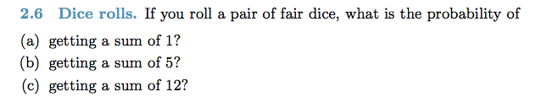

1. It is not possible to get a sum of 1 when rolling a pair of dice assuming that the dice produces the values 1, 2, 3, 4, 5 or 6
2. Sum of 5 can be obtained from: {2,3}, {1,4}, {3,2}, {4,1} which is 4 combinations. So, the probability is 4/36 = 1/9
3. Sum of 12 can be obtained from {6,6}. This is the only possible combination so the probability is 1/36

***Question 2.8***

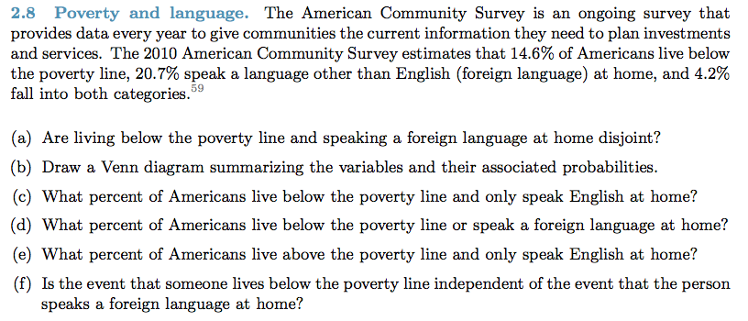

1. No. People who speak foreign language exists in both Below Poverty Line and Above Poverty Line
2. Venn Diagram

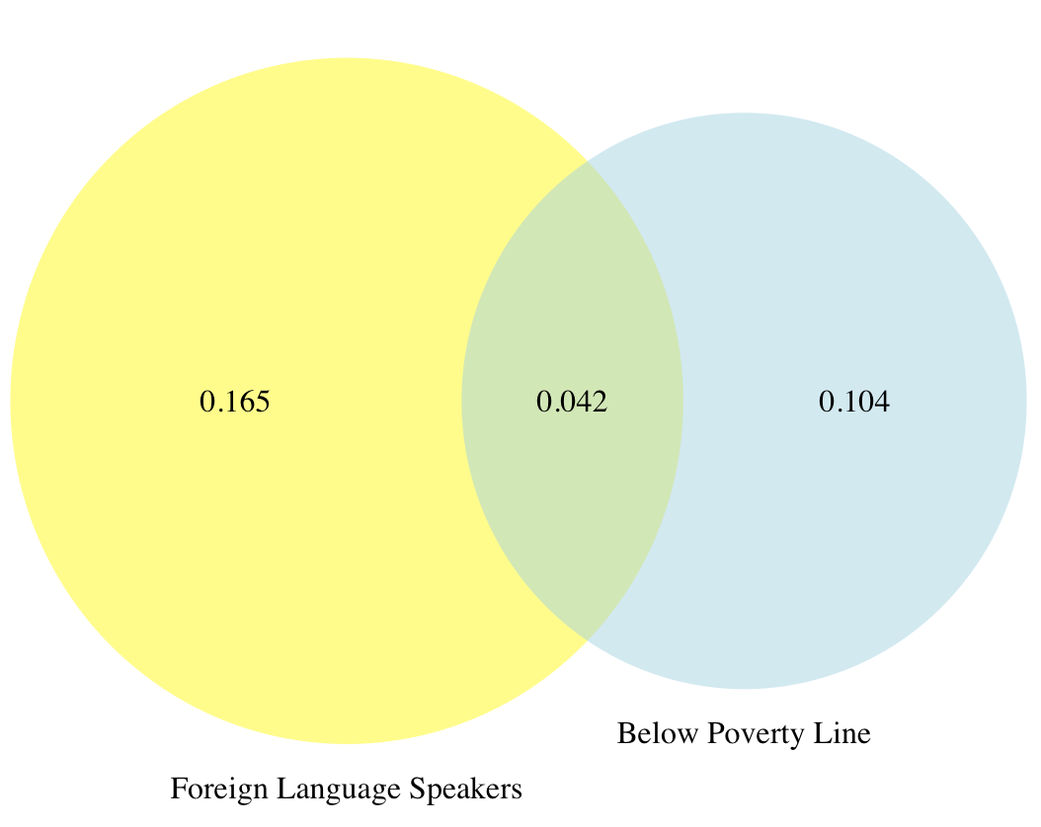

1. 0.146 people live below poverty line and 0.042 speaks non-English language at home so the percentage of people speaking English at home is 10.4% (0.146-0.042)
2. General Addition rule needs to be used to calculate this percentage:

P(below PL or speak FL) = P(below PL) + P(speak FL) – P(both)

= 0.146 + 0.207 – 0.042

= 0.311

1. This can be calculated using the results of previous step (d). The percentage of Americans live above PL and speak only English will be 1 – P(below PL or speak FL) which is 0.689
2. The events are not independent because

P(below PL and speak FL) <> P(below PL) * P(speak FL)

0.042 <> 0.030 (0.146 * 0.207)

***Question 2.20***

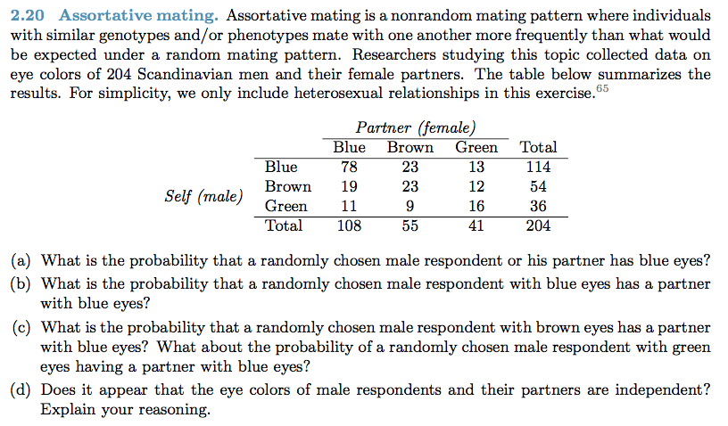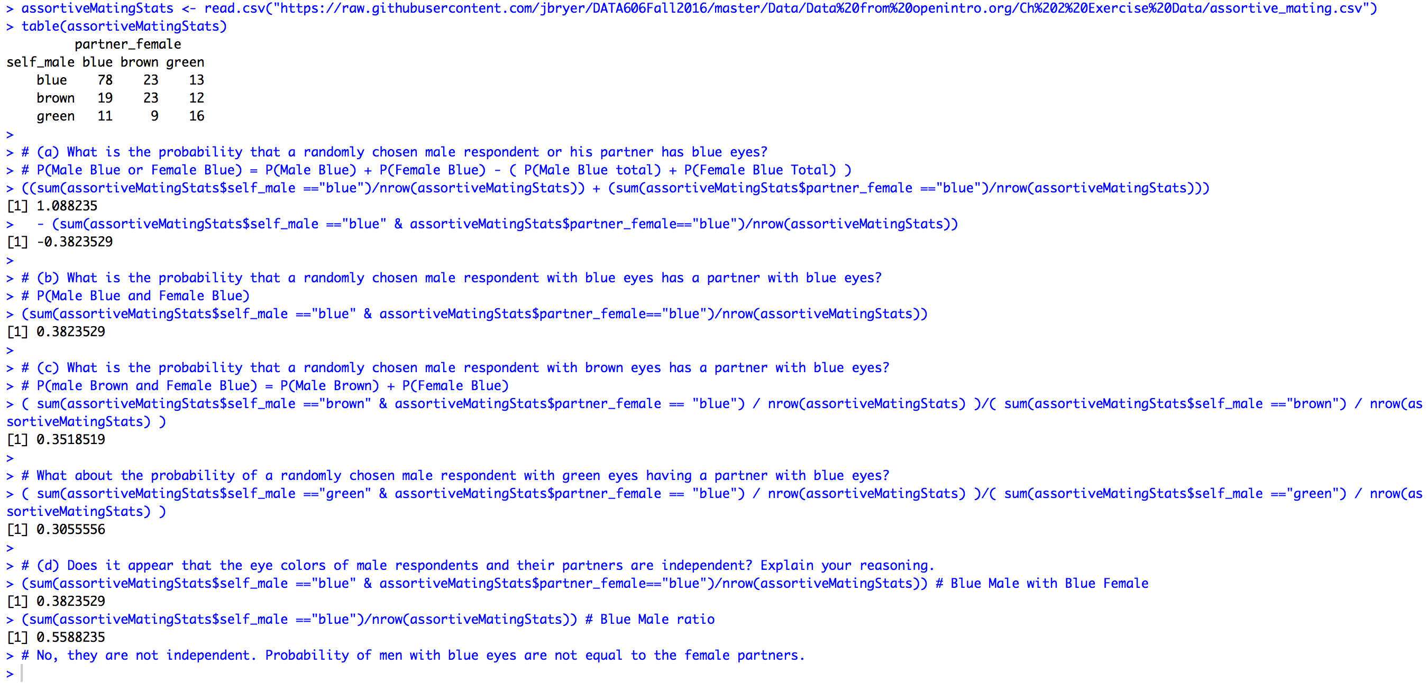

***Question 2.30***

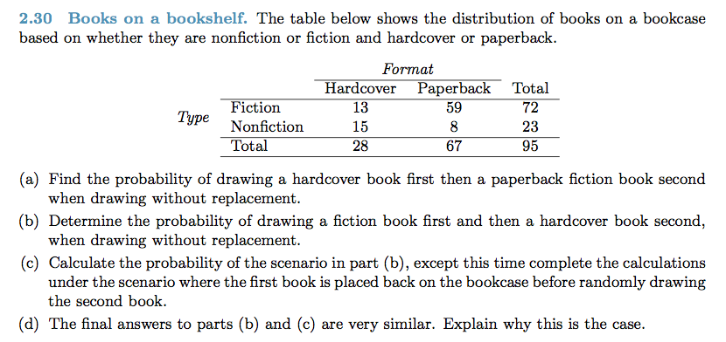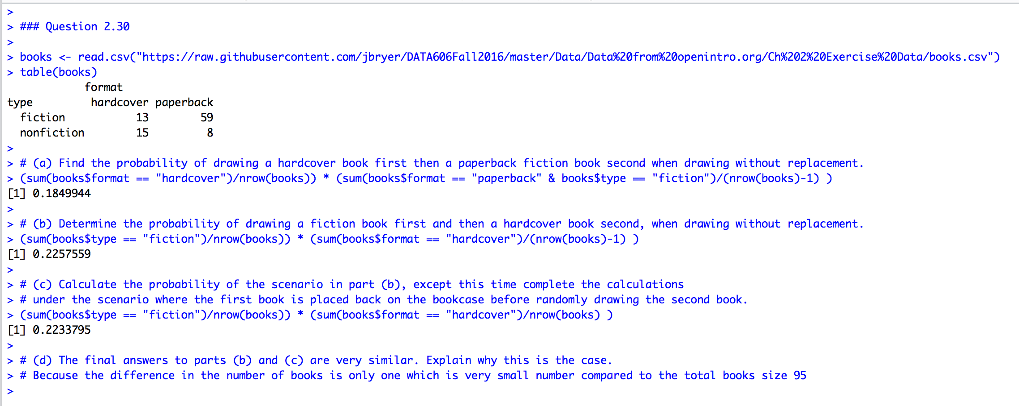

***Question 2.38***

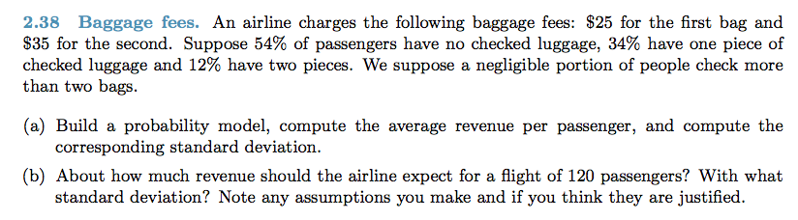

1. Answers:

Average Revenue Per Passenger:

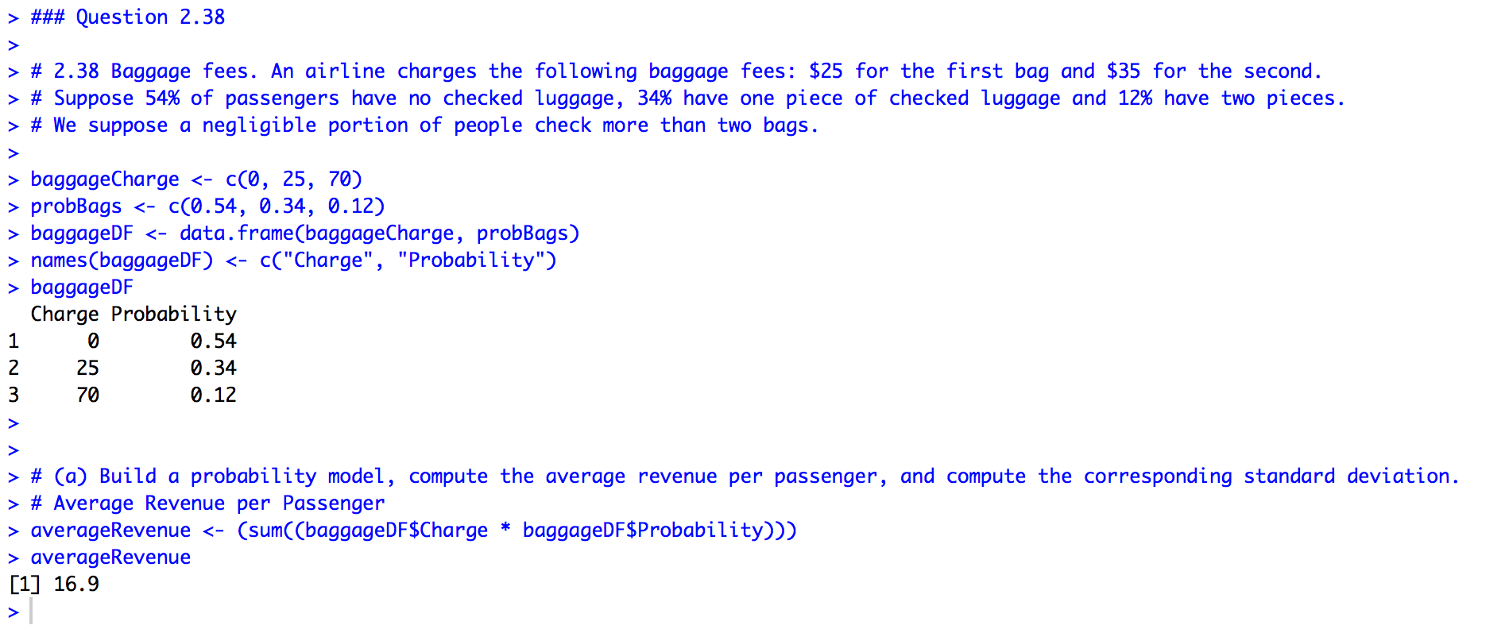

Standard Deviation:

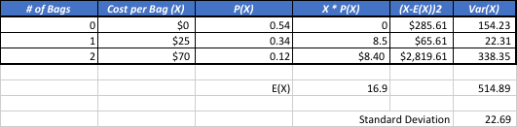

1. Standard Deviation for 120 passengers:

***Question 2.44***

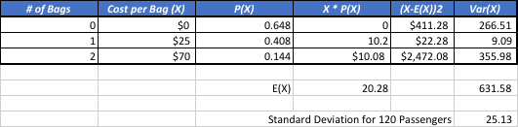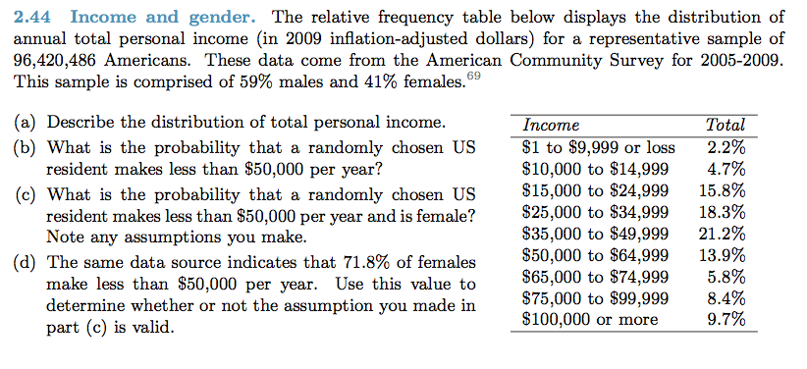

1. Income is nigh in the middle range (25K – 65K). Most people (53.4% of the population)

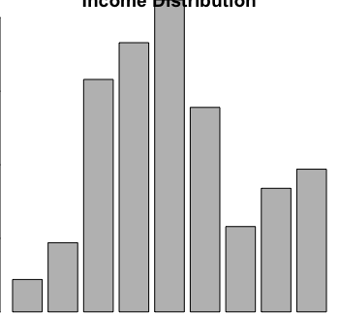

1. Probability that a randomly chosen US  resident makes less than $50,000 per year is 0.622 ((2.2 + 4.7 + 15.8 + 18.3 + 21.2) / 100)